**REACTJS Vs Angular JS**

**REACT JS**

REACT (also known as REACT.js or REACTJS) is a**free and open-source front-end JavaScript library** for building user interfaces based on UI components. It is maintained by Meta (formerly Facebook) and a community of individual developers and companies. It is used to build single page applications.

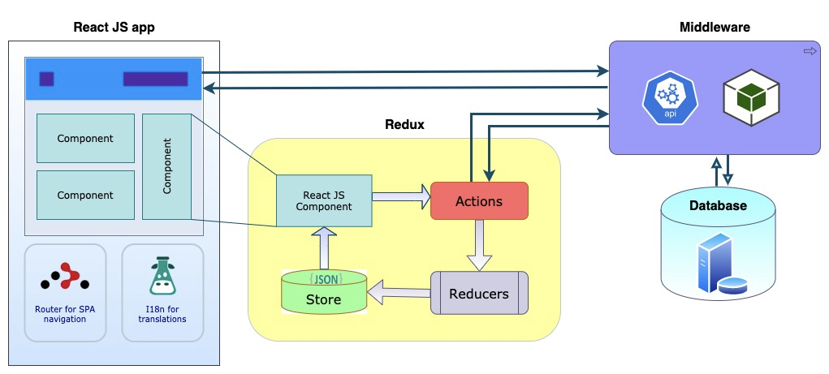

**REACTJS Architecture**

**How does it work?**

REACT implements a virtual DOM that is basically a DOM tree representation in JavaScript. So, when it needs to read or write to the DOM, it will use the virtual representation of it. Then the virtual DOM will try to find the most efficient way to update the browser’s DOM. REACT DOM takes care of updating the DOM to match the REACT elements. With the **Diffing algorithm**, REACT can finalize what update is necessary and update only the object on the real DOM. So, when there is an update in the virtual DOM, REACT compares the virtual DOM with a snapshot of the virtual DOM taken right before the update of the virtual DOM. With the help of this comparison REACT figures out which components in the UI needs to be updated. This process is called Diffing. The algorithm that is used for the diffing process is called as the diffing algorithm. Once REACT knows which components has been updated, then it replaces the original DOM nodes with the updated DOM node.

**Pros:**

* It needs short learning Path (JSX, Props, Redux, Routing, Managing state).
* It has faster updates with both server-side and front-end support.
* It offers easy debugging process and the code is reusable.
* Through virtual DOM, it ensures that the actual DOM only repaints the necessary data.

**Cons:**

* Need a set of tools for testing.
* Need an In-depth knowledge to integrate with MVC framework.
* Difficult to integrate with traditional framework like RAIL.

**Angular JS**

AngularJS is a**JavaScript based open-source front-end web framework** mainly maintained by Google and by a community of individuals and corporations. It is an excellent framework for building single phase applications and line of business applications.

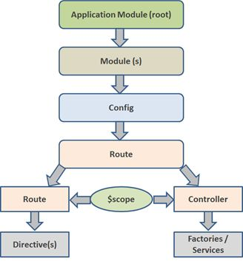

Angular JS Architecture

**How does it work?**

A module in Angular application is a group of the components, directives, pipes, and services, which are related to the application and collectively build a common functionality. Angular provides a lot of build in modules such as http module (to make http call from application) and a big enterprise application is nothing but collection of such modules. AngularJS application gets initialized when DOMContentLoaded events gets fired. A DOMContentLoded event is fired on the document when all the HTML elements are loaded and parsed. It does not wait for all the resources like images, styles and other to be downloaded to browser. Once, this event is fired Angular executes the below steps.

1. Angular looks for ngApp directives in the DOM tree. ngApp works like a marker to AngularJS, which tells the AngularJS that the portion of HTML mark-up needs compilation.
2. If Angular finds multiple ngApp directives then it takes the 1st ngApp covered HTML portion and starts the process of auto-bootstrapping. In auto-bootstrapping all other depended modules and injectors gets loaded to the AngularJS application.
3. The other remaining ngApp directives needs manual bootstrapping. A manual bootstrapping can be done using angular.bootstrap() method.

Once the ngApp root is determined the compilation process of HTML markup gets triggered by considering the ngApp element as the root of the application. During the compilation process it loads all the dependencies like injector or modules.

**Pros:**

* Single tool is good enough for testing.
* Compatible for large scale projects and rich featured applications.
* With Two-way Data binding, it automatically synchronizes the data between model and view components.
* AngularJS comes with several built-in services such as $http to make a XMLHttpRequests.

**Cons:**

* Google has officially ended their support for AngularJS in January 2022.
* Learning Path of AngularJS is large (Directives, Decorators, Components, Services, RX.JS, Change Detection, Pipes Templates, Dependency, Modules, Typescript, MVC).
* Integration with third party applications is difficult.
* Switching from older version to new version is difficult.
* Difficult to handle bugs.

**AngularJS Vs REACTJS**

|  |  |
| --- | --- |
| **REACTJS** | **AngularJS** |
| Developed by Facebook in 2013. | Developed by Google in 2009. |
| JavaScript library (View in MVC; requires Flux to implement architecture). | Full-fledged MVC framework written in JavaScript. |
| Client-side rendering | Server-side rendering |
| Virtual DOM | Real DOM |
| One-way data Binding | Two-way data binding   * Event * Property |
| Applications which uses REACTJS   * Facebook * Instagram * Netflix | Applications which uses AngularJS   * Google * YouTube * Sony |

**Statistics about REACT JS and Angular JS**

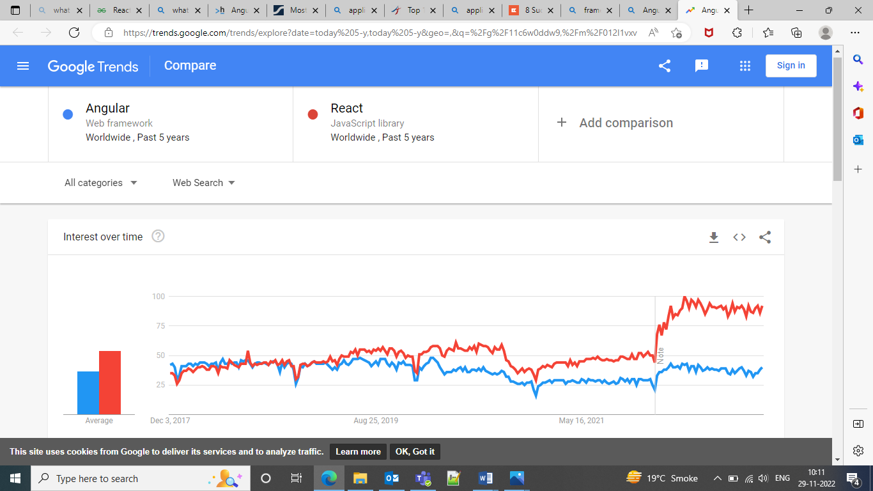

Google search trends between Angular JS and REACT JS, for the past 5 years [source](https://trends.google.com/trends/explore?date=today%205-y,today%205-y&geo=,&q=%2Fg%2F11c6w0ddw9,%2Fm%2F012l1vxv)

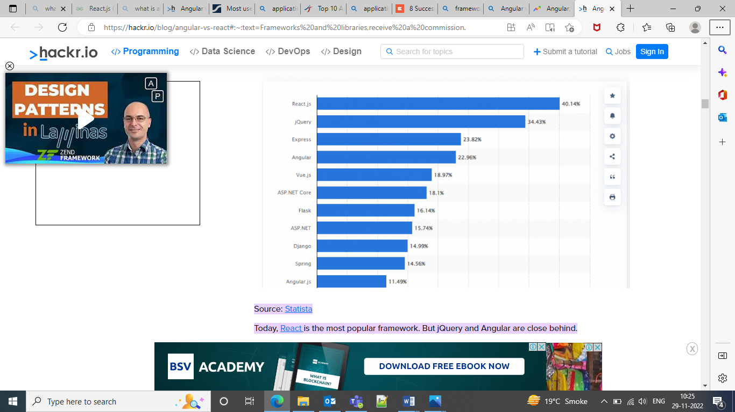Most used frameworks survey, 2022 [source](https://hackr.io/blog/angular-vs-react#:~:text=Frameworks%20and%20libraries,receive%20a%20commission.)

**Conclusion**

We are choosing React JS over Angular JS since it has virtual DOM which helps to boost the performance of any application regardless of its size.

When using React Js vs angular, React Js is on Open Source Framework while Angular JS is on MVC framework. React Js supports Javascript while AngularJS support JavaScript as well as HTML.

React JS is relatively easy to learn and allows quick app development in the ecosystem. Whereas Angular JS has a Steep learning curve, complicated component management system and demands a good command over different languages and concepts like pipes & templates.

With a virtual DOM & library, React JS can accommodate scalable development. It is a preferred view framework to build scalable and reusable components, whereas Angular JS is Easy to scale owing to its design and a powerful Command Line Interface.

AngularJS support has officially ended as of January 2022. The GitHub repository will be in an archived state, meaning that no new issues or pull requests can be submitted. The code will remain accessible on GitHub, npm, Bower, and Release archive.

In case, if project needs future functionality expansion and has dynamic content that changes your view or needs an app that will update the look simultaneously and constantly go with React JS or If You are in the inception phase of development. Also, if you wish to start application development, and require a holistic framework that will get you started quickly seeking a robust and well-maintained framework for the project-range of any size.